[**猎豹MFC--TH_双管道--对管道的操作就想对文件的操作一样**](https://www.cnblogs.com/hungryvampire/p/5299280.html)

[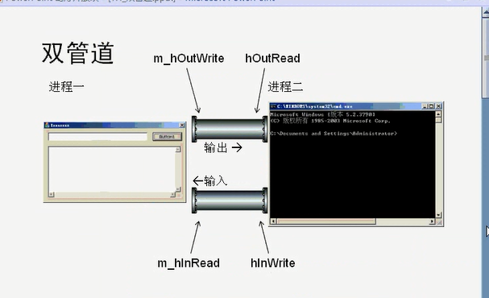](http://images2015.cnblogs.com/blog/751322/201603/751322-20160320191514990-801223218.png)

使用双管道 给两个进程进行通信，不需要再开辟进程  效率高“反复使用一个进程进行通信

两个管道  四个句柄  ，

两个成员变量 两个局部变量”

修改单管道1的代码“

[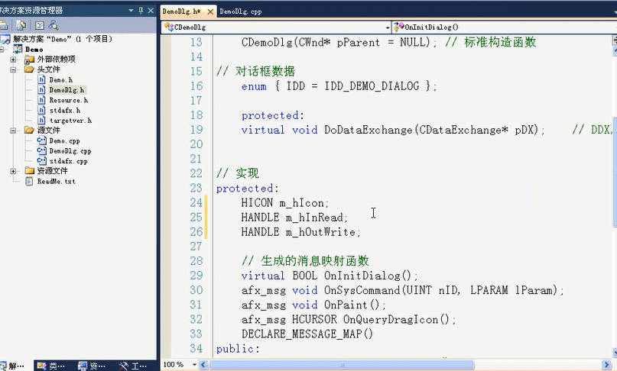](http://images2015.cnblogs.com/blog/751322/201603/751322-20160320191515631-1308480350.png)

[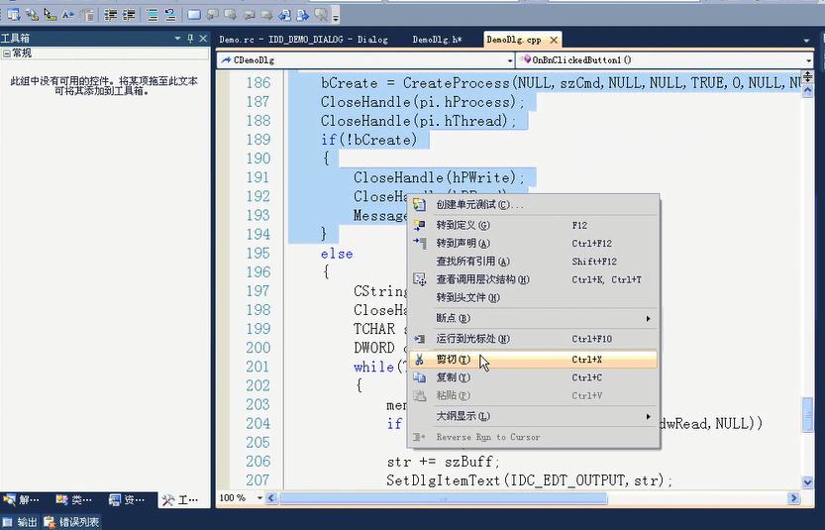](http://images2015.cnblogs.com/blog/751322/201603/751322-20160320191516646-1600213000.png)

粘贴到构造函数中：

[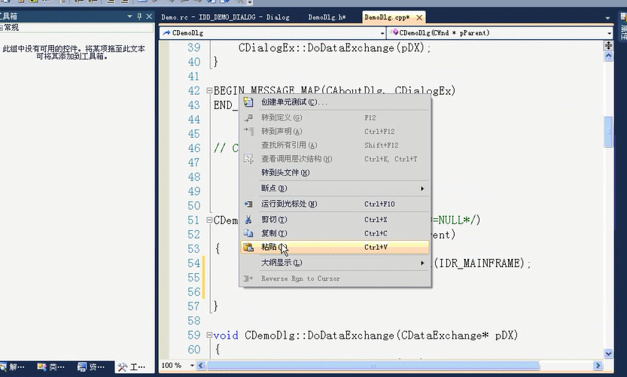](http://images2015.cnblogs.com/blog/751322/201603/751322-20160320191517724-882487314.png)

粘贴到构造函数中后修改变量的名称：

[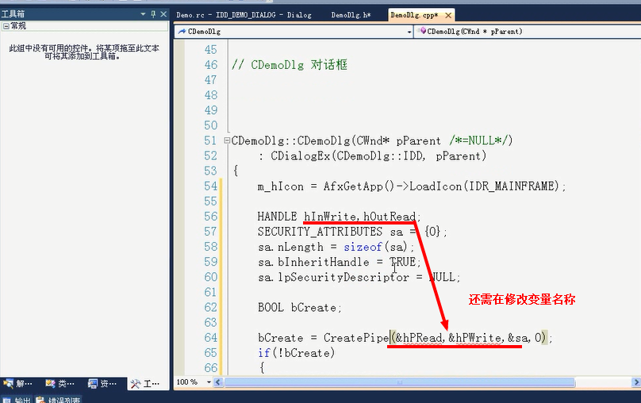](http://images2015.cnblogs.com/blog/751322/201603/751322-20160320191518990-1860816490.png)

修改为如下：

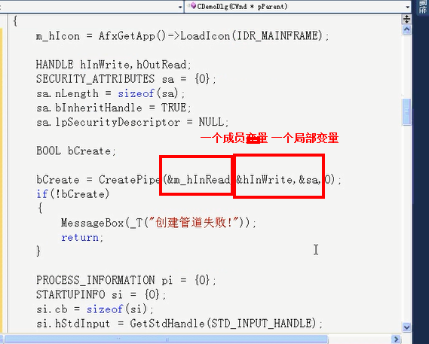

[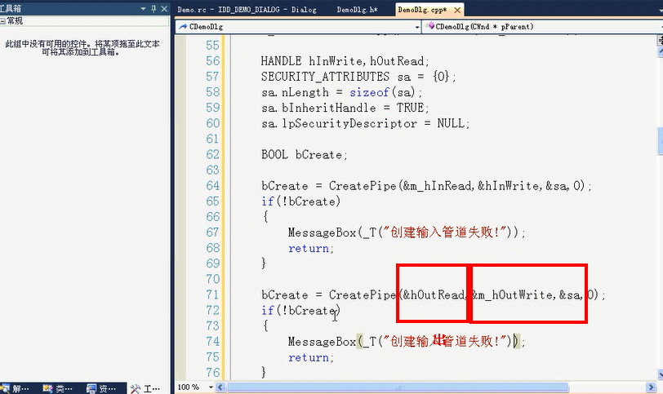](http://images2015.cnblogs.com/blog/751322/201603/751322-20160320191520209-2050448530.png)

[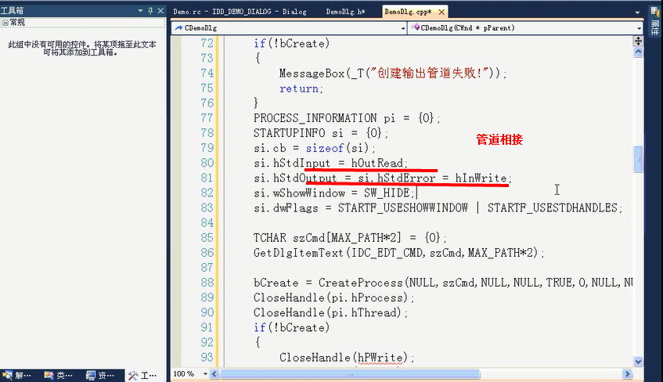](http://images2015.cnblogs.com/blog/751322/201603/751322-20160320191521443-1971834538.png)

[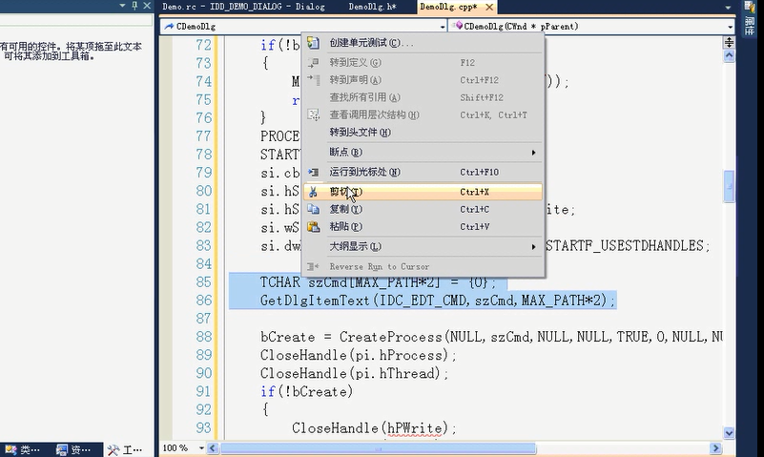](http://images2015.cnblogs.com/blog/751322/201603/751322-20160320191522428-527122557.png)

上面选中的代码是执行命令时要使用的  粘贴到如下”

[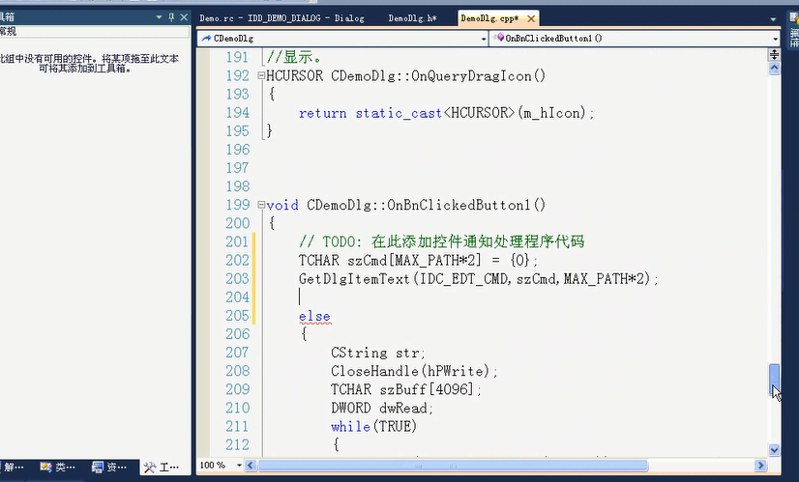](http://images2015.cnblogs.com/blog/751322/201603/751322-20160320191523256-1194885084.png)

把字符串szCmd提到全局变量 因为下文还有使用：

[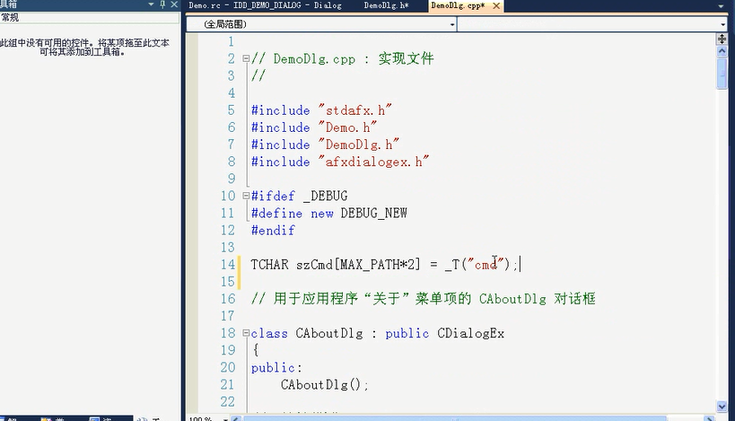](http://images2015.cnblogs.com/blog/751322/201603/751322-20160320191524615-1743201706.png)

关闭局部变量：

[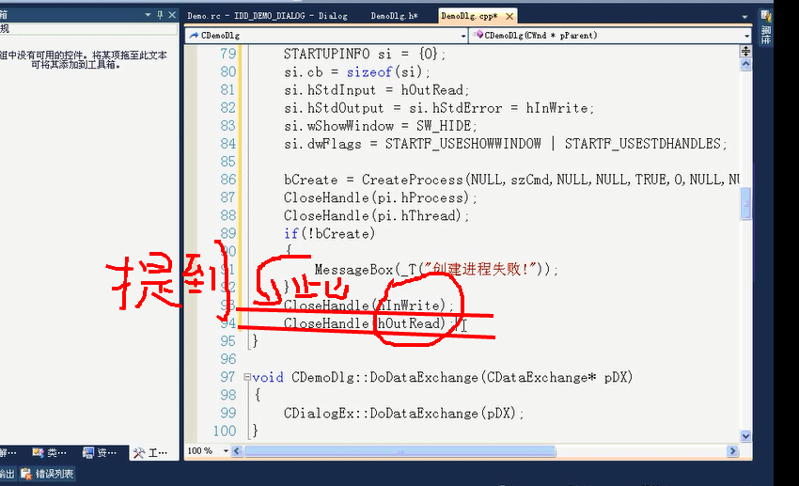](http://images2015.cnblogs.com/blog/751322/201603/751322-20160320191525521-1221766604.png)

类的成员变量要在析构函数中关闭：‘

[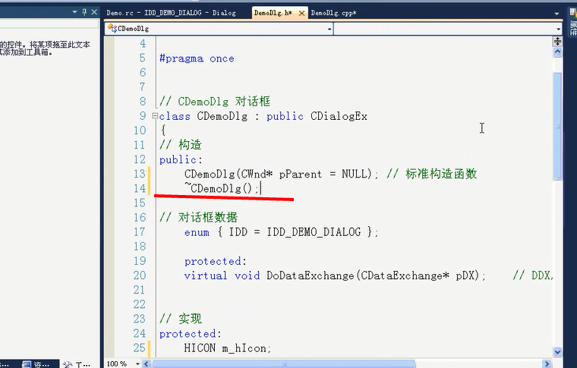](http://images2015.cnblogs.com/blog/751322/201603/751322-20160320191526568-441473364.png)

[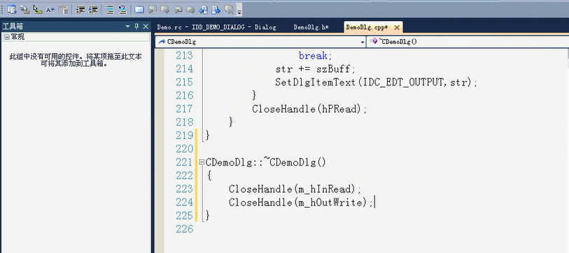](http://images2015.cnblogs.com/blog/751322/201603/751322-20160320191527365-2102611667.png)

先注释掉未写好的代码“：

[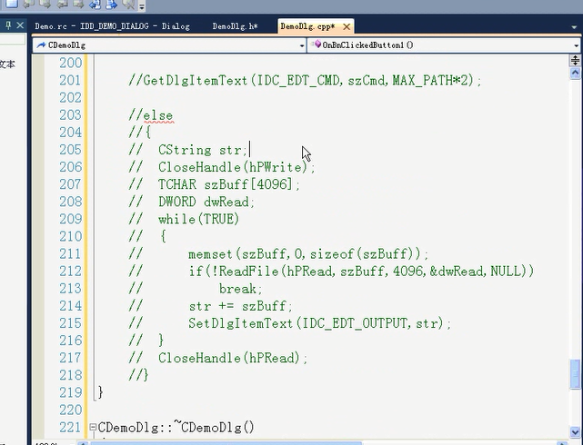](http://images2015.cnblogs.com/blog/751322/201603/751322-20160320191528006-163567119.png)

[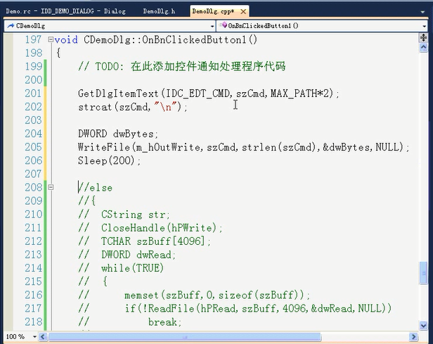](http://images2015.cnblogs.com/blog/751322/201603/751322-20160320191528849-1152508547.png)

取消注释 读输出管道[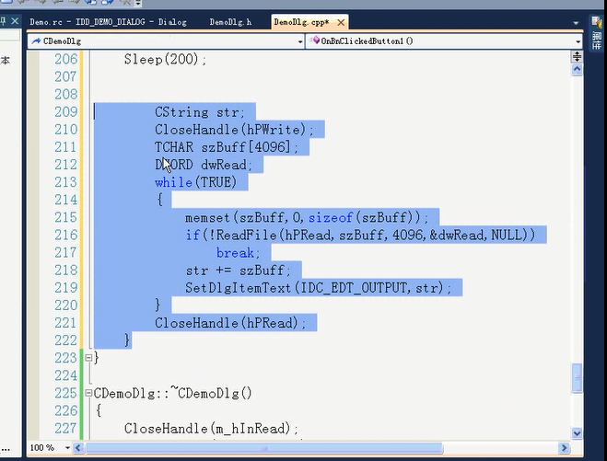](http://images2015.cnblogs.com/blog/751322/201603/751322-20160320191530162-1945941180.png)

修改代码：”

、[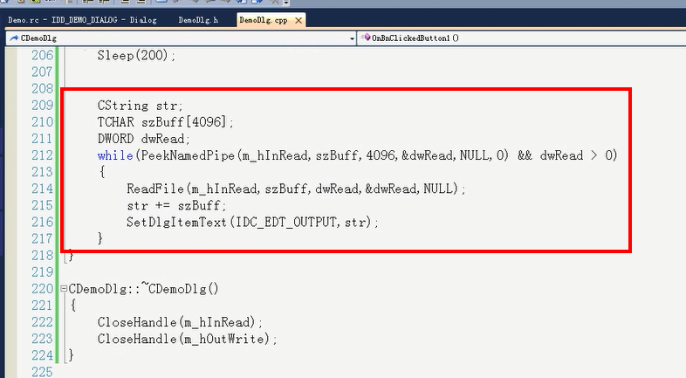](http://images2015.cnblogs.com/blog/751322/201603/751322-20160320191531256-980750202.png)

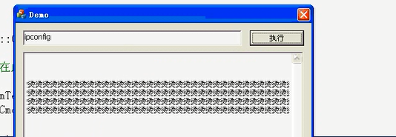

[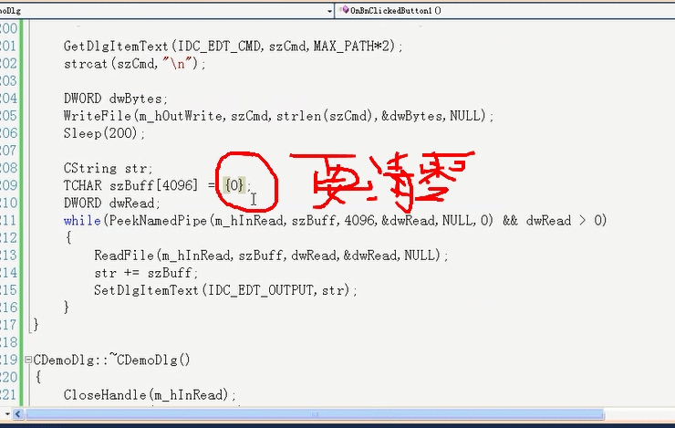](http://images2015.cnblogs.com/blog/751322/201603/751322-20160320191532646-60282648.png)

[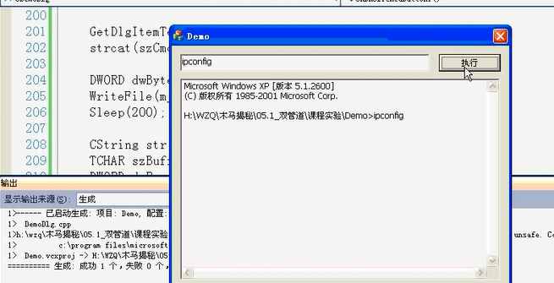](http://images2015.cnblogs.com/blog/751322/201603/751322-20160320191533693-931754110.png)

修改Sleep时间：否则 会有读不到的情况出现

[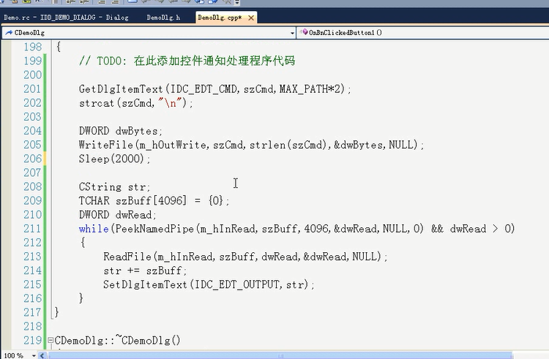](http://images2015.cnblogs.com/blog/751322/201603/751322-20160320191534365-526544669.png)

[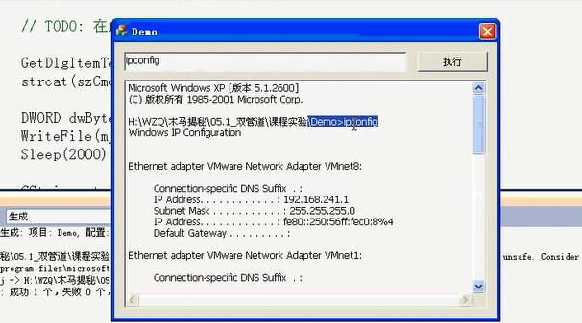](http://images2015.cnblogs.com/blog/751322/201603/751322-20160320191535115-1210462369.png)

[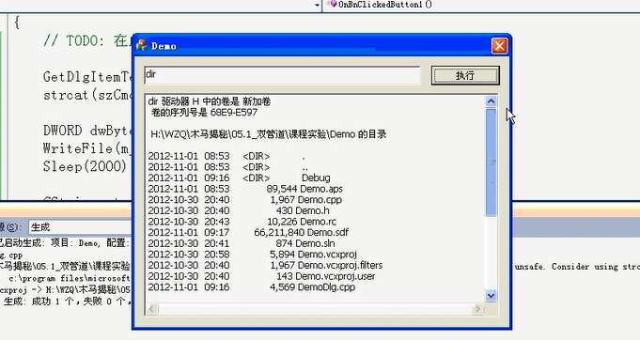](http://images2015.cnblogs.com/blog/751322/201603/751322-20160320191535787-1126260563.png)